Version Manager

* AEM creates a new version of a page when you activate/publish a page after updating the content of a page.
* These versions are stored in the repository and can be restored if required.
* These versions are never deleted so the repository size will grow over time and therefore need to be managed.
* So to manage this we can use version manager.
* The version manager can be configured to delete old versions when new versions are created.
* Version manager can be configured with the Day CQ WCM version manager osgi service.

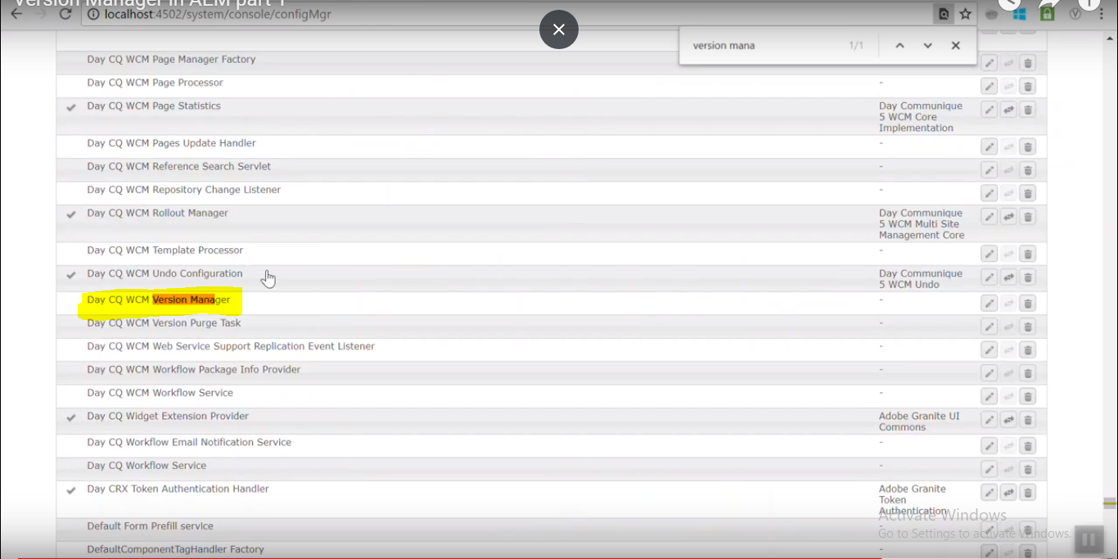

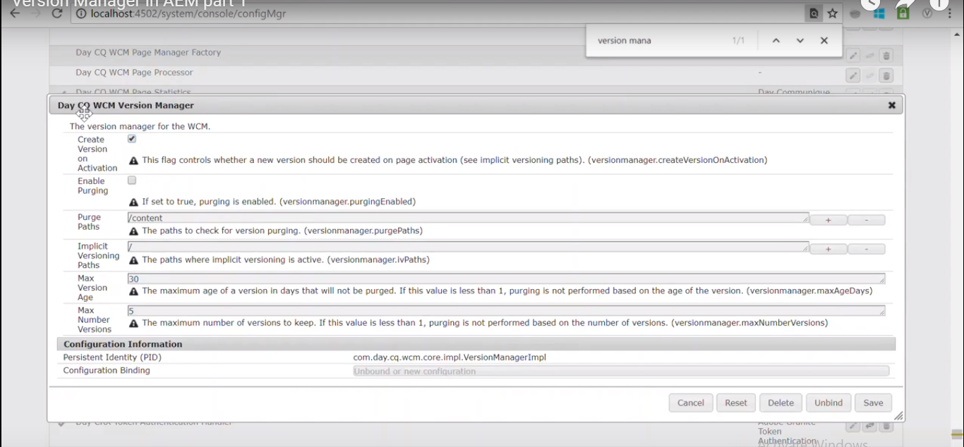

* When you publish the page, you can see the version of page by selecting the page and clicking on timeline.

**Configuring version manager**

* To configure the version manager for Geometrix page.
* Copy the persistent Identity pid of day cq wcm version manger osgi service.
* Go to the crx/de console and create a folder in Geometrix folder and name it config.author.
* Below this node create a sling:osgiconfig node and name it ad the pid which we copied earlier.
* Add the 6 properties here as shown in the video and create more version of the triangle page.
* Now if you open the timeline of triangle page you will find latest 2 versions and old versions will be purged.

